An OO Application Frameworks Perspective on Commonality and Variability in Product Line Architectures
Position Paper Version 2.1 2000-08-19
H. James Hoover1, Tony Olekshy2, Garry Froehlich1, Paul Sorenson1
1Software Engineering Research Laboratory
Department of Computing Science
University of Alberta
Edmonton, Alberta, Canada T6G 2H1
{hoover, garry, sorenson}@cs.ualberta.ca
2Avra Software Lab Inc.
Edmonton, AB, Canada, www.avrasoft.com
olekshy@avrasoft.com
Abstract. This position paper briefly describes our experience with using frameworks to build applications, and in communicating how to use the frameworks to other developers. Frameworks capture varying degrees of commonality and variation depending on whether they are foundation frameworks or domain specific frameworks. In addition to the usual requirements focus for commonality and variation, we observe that these notions also apply to software architecture, and to implementation technology. We use our experience to raise questions about how processes and tools that deal with commonality and variation can be used by the developer in a production situation faced with ongoing product evolution.
Introduction
These remarks stem from our experience, both commercial and academic, with developing frameworks and then using them to build suites of applications in related domains. Our commercial experience is in building tools for the sizing and selection of engineered products. We have two frameworks, Kalos for building thick-client applications, and Prothos for building web-based thin-client applications. Our academic experience is with using a small Java-based framework, CSF, for client-server applications, which we use in teaching our 4th year software engineering course.

The users of a framework face both tactical and strategic problems. Tactical problems are generally at the level of "How do I solve this problem with the framework?" We use hooks to address this [Froehlich97]. If you have a specific problem, hooks can tell you the possible solutions provided by the framework.

Strategic problems are at the higher level of "How do I go about using the framework for my application?" We provide very little strategic assistance, yet this is probably the area where decision models and process are most useful. How else can one answer questions like: Is this framework suited to my intended application? How do I choose among alternative common services provided by the framework? How do I add new domain-specific services to the framework?
A Simple Example
The Client Server Framework (CSF) is a small (<10 kloc) Java-based framework for building applications that can be mapped onto the client-server architectural pattern. The CSF is a foundation framework, in the sense that it only provides the client-server functionality of the application, and does not dictate much of the other form or function.

The tactical use of the CSF is documented with hooks. A hook is a use case for some feature of the framework. Each hook documents a narrowly focussed means of using the framework. For example, a hook will indicate how to create a menu within a user interface framework, or how to instantiate a new mailbox in a client-server framework. A typical hook consists of a structured template that elicits all of the required information needed to select and use the hook, including sections on the requirements the hook satisfies, the framework parts used, and any constraints that must be satisfied. A typical hook is shown in Figure 1.

Our classroom observation is that, even with the hook documentation, developers do not know where to start using the CSF to build their application. So we provide an informal process that addresses this strategic issue. This high level process, illustrated in Figure 2, guides the user in mapping their application requirements onto the services supported by the framework. For example, the first two steps, Discover Data and Identify Persistence, help the user decide what information they need to communicate across the network, and which information needs to be persistent. These steps then point to specific hooks where the associated tactical decisions are addressed, such as how to generate a new data element, or whether to use flat files or a database to implement persistence. It's not clear if this informal process can be made more precise, or if it could, whether that would actually help in building applications.

Fig. 1. An example of a CSF hook
Name: Broadcast Message Hook

In CSF, broadcasting messages is also done through Outboxes. Essentially, the Outbox contains a list of Inboxes to send a message to, and it sends to each of those Inboxes sequentially (so it isn't yet a true multi-cast). CommAwareObjects send the messages, and the Outboxes ensure that they are sent to the right Inboxes. The CommAwareObject and Outbox should have already been created (see New CommAwareObject hook and New Outbox hook).

So first add all of the addresses to the Outbox that it should broadcast to.
out.addAddress(anAddress);
The actual method call to to send is exactly the same as the Send Message hook.

Requirement: An object needs to send a message to several different objects on remote machines.
Type: Enabling Pattern
Area: Communication
Participants: NewCAO
Preconditions:
subclass NewCAO of CommAwareObject;
operation NewCAO.send;
operation NewCAO.setup;
Outbox NewCOA.out; // if not, see New Outbox
Changes:
// put the addresses of every object you want to send to in the Outbox
repeat as necessary
NewCAO.setup -> new Address(IP,Port,Name);
NewCAO.setup -> out.addAddress(Address);

// create the message type, and the data to be sent
fill in returnAddress : Address;
fill in type : string; // this is the MESSAGE type
fill in data : Data; // The DATA object to send

// Send the message. Note that the Outbox already has the addresses to send
// it to, which was given when it was created.
NewCOA.send -> NewCOA.out.sendMessage(returnAddress, type, data)
NewCOA.send handles SendException

Postconditions: none
Comments: Messages are sent asynchronously, so control will return to NewCOA right away (as soon as the message has been successfully sent).

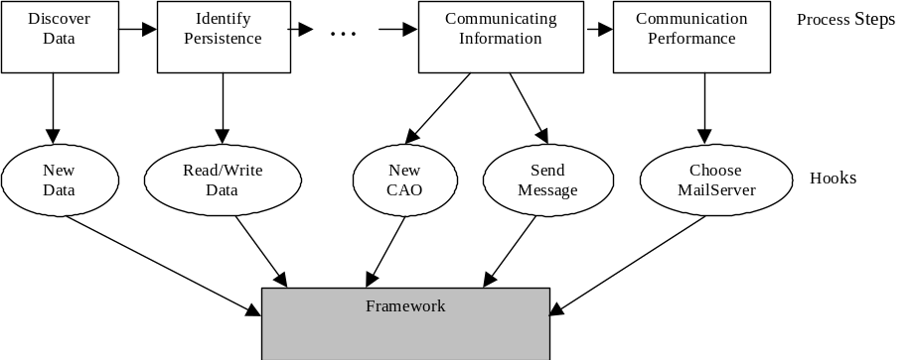
Fig. 2. Process for building an application with the Client Server Framework.

In summary, for the CSF we have the following situation:
- The construction of an application is supported by a simple strategic process that maps onto the client-server variation points as described by hooks.
- As a foundation framework, the CSF does not really constrain the potential applications, it only captures the commonality associated with the client-server aspects. Thus is can be difficult to decide if the framework is appropriate for the intended application.
- Foundation frameworks alone are not sufficient for product line architectures, as not enough commonality is prescribed and too much variability allowed.
A Production Example
Our Kalos and Prothos application frameworks are used to build database-centric applications. In such applications, a database is used to store the business objects. A client, run on the user's desktop, is used to access and manipulate the business objects. A user sees an application as a collection of forms that select, view, and modify business objects in the database. Because there is little scope for changes in the db-centric pattern, the decision of whether to use such framework is much easier than for the CSF — applications that don't satisfy the db-centric model are not suited to the framework.

We use these frameworks to build applications for the sizing and selection of engineered products. An engineered product is one in which some kind of standards-based calculation is required in order to determine the properties of the product, followed by a selection of the product from the catalog of things that the manufacturer can build. For example, determining the required properties of a beam that must span a given gap carrying a given load, followed by ordering that beam from the manufacturer. We take the basic db-centric model supported by the framework, and add to it additional services that support the sizing calculations (engineering worksheets) and the selection process (product catalog).

By thinking in terms of services, and factoring the frameworks, as much as possible, into independent services, we achieve a kind of architectural notion of commonality and variability. All of our applications have an architectural model of this form in Figure 3.

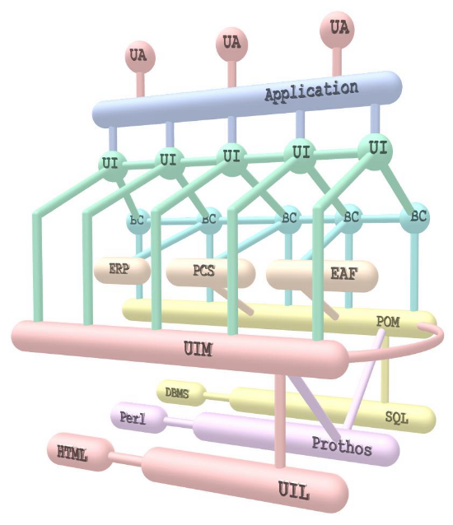
Fig. 3. The common architectural model for Kalos- and Prothos-based applications.

An application is a collection of common services, plus some application specific services, plus all the usual customizations for forms etc. Customizations are at the tactical level, with the usual hooks for adding menus, defining new business objects, etc. The core services, such as the persistent object manager (POM), UI manager (UIM), and diagnostic and error handler (Prothos), appear in all applications. Other services, like the engineering worksheet (EAF), or the catalog (PCS), appear only in applications that require them, and when they do, they are very application specific. Individual business classes (BC) model the objects in the database, and forms (UI) tie everything together to make a specific application that talks to one or more user agents (UA).

One of the challenges that framework developers face is that changes in technology can render their framework implementations obsolete. One way to mitigate this is to identify common architectural features that can be implemented with a variety of technologies. Both Kalos and Prothos have the same fundamental architecture but use different implementation technologies. That is, implementation technology is in itself a variation point!

Although we have no strategic process for using these frameworks, we have some support in place for the crucial activity of building engineering worksheets. Because of engineering concerns, such as traceability and revision control, all computations having to do with sizing are captured in a engineering worksheet. Relevant sections of the engineering standard are encoded into the worksheet, which then becomes a service that is attached to the framework. The forms in the application then communicate with the worksheet and provide various views of the computations to the user.

A worksheet is ultimately built using the hooks of the Engineering Application Framework (EAF). But instead of enacting a series of individual hooks the worksheet developer uses a high level descriptive language that compiles into EAF hooks. This not only makes it simpler to specify a worksheet, it allows the underlying hooks to be altered without requiring the developer to re-enact them. In addition, proper enacting of the worksheet hooks requires complying with constraints on the dependencies between data and computations. We do not rely on the user to do this correctly, but rather the framework checks that the structural constraints are satisfied. This prevents the user from introducing difficult to detect defects, but at the expense of some generality in the worksheet. The decision on what limitations to accept were made on the basis of an informal commonality analysis of typical worksheets.

In summary, for the engineered product application line we have:
- It is easy to decide whether an application is suited to the frameworks, it must be db-centric with low transaction volume.
- Factoring into services, common and application specific, is a way of distancing the architecture from the implementation technology.
- There is some rational basis for deciding between the Kalos or Prothos frameworks, based on bandwidth and connection availability, concurrency requirements, product installation and support requirements.
- It is important to provide the application developer with tools for strategic activities, such as constructing a worksheet service, and for automatically checking compliance with constraints.

Discussion Issues
The biggest problem we face with our products is their continuous evolution as standards change, products evolve, users expand their requirements, and implementation technology changes. How do processes and tools that deal with commonality and variation take this into account in order to be useful to the production developer?

Our tools are still very much at the tactical level, such as supporting the correct enactment of hooks, and do not involve much semantic information. At the strategic level, knowledge and its formal representation is required. How much leverage can the developer actually get by becoming more formal in light of the previous problem?
Acknowledgements
We wish to gratefully acknowledge research support from the Natural Sciences and Engineering Research Council of Canada, in particular the Industrial Oriented Research program; the National Research Council of Canada and its IRAP program; and the students in our software engineering courses.
References
[Arango 1993] G. Arango. Domain Analysis. Software Reusability, W. Schaeffer, R. Prieto-Diaz, and M. Matsumoto, eds. Ellis Horwood, New York, 1993.

[Froehlich 1997] G. Froehlich, H.J. Hoover, L. Liu, and P. Sorenson. Hooking into Object-Oriented Frameworks. In Proceedings of the 1997 International Conference on Software Engineering (Boston, Mass, 1997), pp. 491-501, 1997.

[Froehlich 1997] G. Froehlich, H.J. Hoover, L. Liu, and P. Sorenson. Hooking into Object-Oriented Frameworks. In Proceedings of the 1997 International Conference on Software Engineering (Boston, Mass, 1997), pp. 491-501, 1997.

[Froehlich 1999] G. Froehlich, H. J. Hoover, P. Sorenson. Realizing Requirements in Product-Line Development using O-O Frameworks. Australian Journal of Information Systems, Special Issue on Requirements Engineering, pp. 6-12, 1999.

[Hoover 2000] H. J. Hoover, A. G. Olekshy, G. Froehlich, P. Sorenson. Developing Engineered Product Support Applications. In Proceedings of the 1st Software Product Line Conference (Denver, CO, 2000), 22 pp.

[Pree 1995] W. Pree, Design Patterns for Object-Oriented Software Development. Addison Wesley Publishing Company, Reading, MA. 1995.

