WebIC --- Predicting IC-Pages

Tingshao Zhu, Russ Greiner ({tszhu, greiner}@cs.ualberta.ca)
Gerald Häubl (Gerald.Haeubl@ualberta.ca)

What is an IC-Page?
- ≡ web-pages user must examine to complete task;
≡ target pages; destination pages
- e.g., pages that describe
  - product the user purchases (on-line shopping)
  - profs’ research information (graduate application)

What is WebIC?
  - IE-Based multi-view browser that predicts IC-Pages for web users,
  - suggesting an unrestricted subset of whole web.
  - also be used for annotation and personalization.

IC-page prediction from IC-words : Web-Scout and Web-Searcher
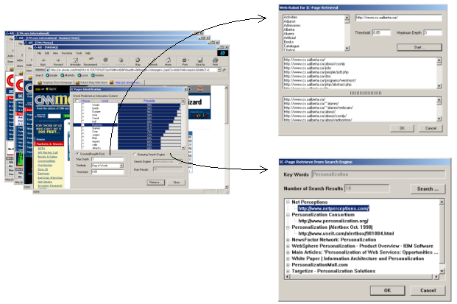

How does WebIC work?
Two step process:
- Predict which words will be in an IC-Page – “IC-Words”
- Either (a) Scout (web-crawl) to find pages that match predicted IC-Words or (b) send IC-words to search engine.

Is WebIC like Association-Rule systems?
NO!
- WebIC is based on “browsing behavior” of the web users
- Not based on specific pages the users have visited, nor specific words in those pages
- but HOW they looked for information in the Web
⇒ patterns can be used in novel web environment.

What is the Annotation and Personalization of WebIC?
- WebIC learns patterns from annotated web logs
(each web page has a bit to indicate whether it is an IC-Page)
– from earlier users, and current user.
- If WebIC user annotates while browsing, WebIC can adapt.
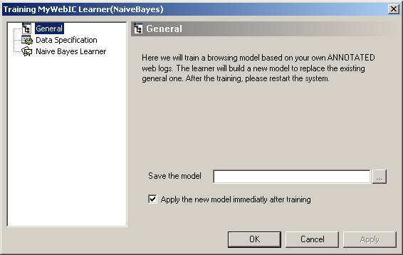
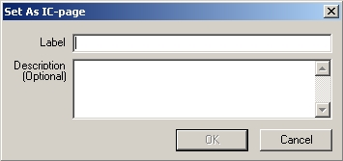
Annotation
Personalization

- WebIC extracts “Browsing Behavior Model” from the user’s annotated web logs
- …is expected to represent the user’s browsing behavior more accurately, and thus can help WebIC provide good recommendations.

How to get WebIC?
- http://www.cs.ualberta.ca/~greiner/web-user-model.html
- http://www.cs.ualberta.ca/~tszhu/webic/

